


Thesis Proposal
CONSULTATION SHEET

Project Title:  Addressing Typographic Hallucination in Generative AI Images: An Open-Set Metric Learning Approach to Font Style Recognition | Week # 1 | Group Members:  - Janritch D. Diputado  - Matt Erron G. Cabarrubias
Date:
June 22, 2026
June 24, 2026
Progress Report (based on the adviser’s previous comments/suggestions) by Students
1st meeting (June 22):
- Finalized the main topic and scope of the thesis
- Decided how to get our dataset by generating synthetic data
2nd meeting (June 24):
- Modified scope
- Gathered literature to support our thesis
Recommendations by Adviser
1st meeting (June 22):
- Figure out how to deal with biases for ai generated fonts
- Modify scope to percentage based classification
2nd meeting (June 24):
- Did not meet for second meeting
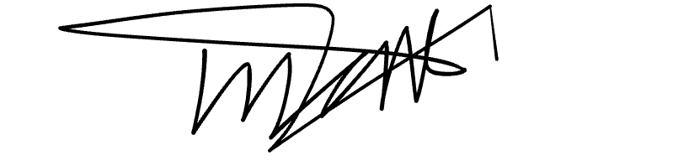

Prepared by:
Janritch D. Diputado | Matt Erron G. Cabarrubias
Noted by:
CHRISTINE D. BANDALAN, MEng
Thesis Adviser

